8. Basics of Relationships, Master-Details Relationships - 05 Feb 2022

Definition: A Relationship is used to connect two objects.



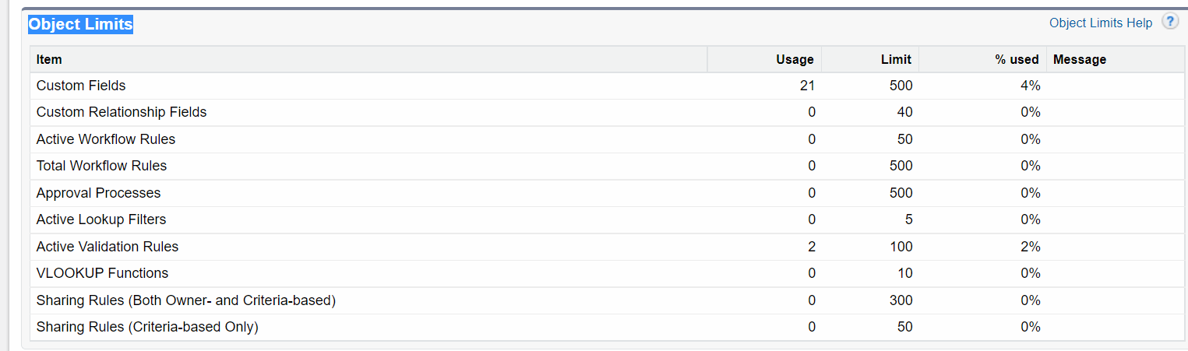

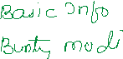

**Types of Relationships**

1] Master – Details Relationship (1 : N)



2] Lookup Relationship (1:N)

3] Many to Many Relationship (Junction Object) : (N:N)

4] Self Relationship (1:1)

5] Hierarchical Relationship

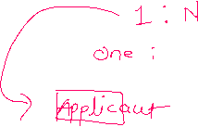

1] Master – Details Relationship (1 : N)



Applicant (Master) 🡨 🡪 Address (Details)



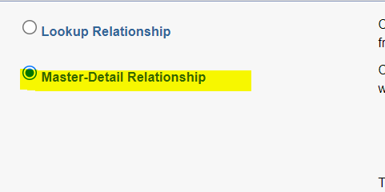

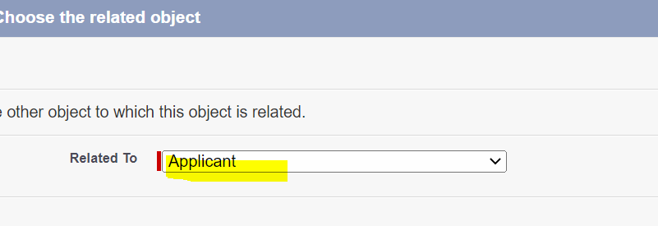

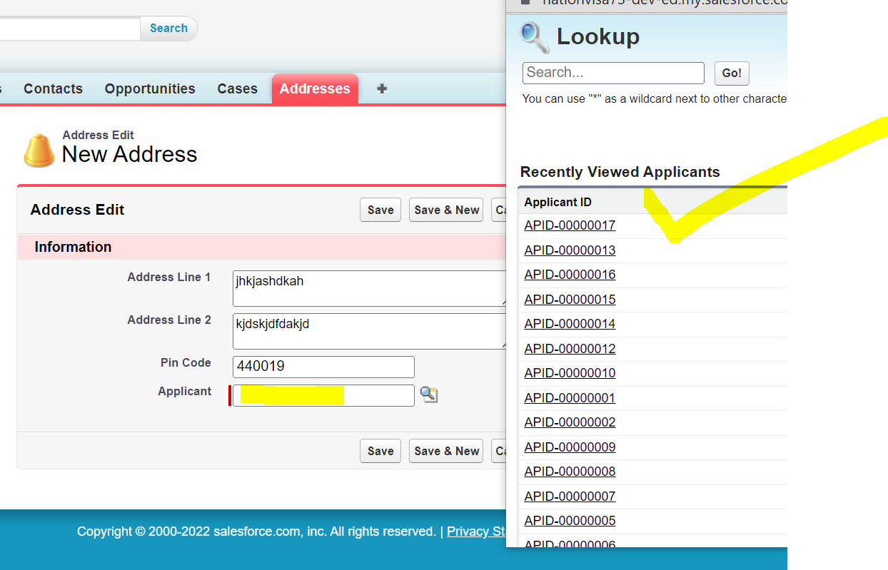

**Applicant Object:**

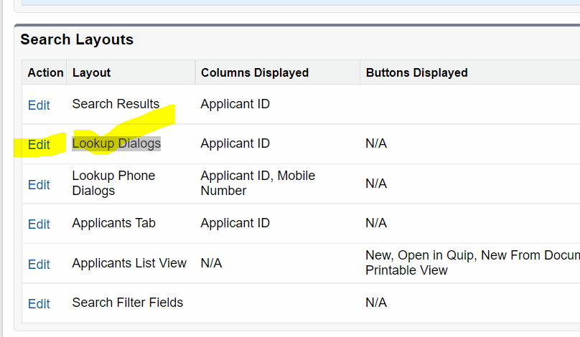

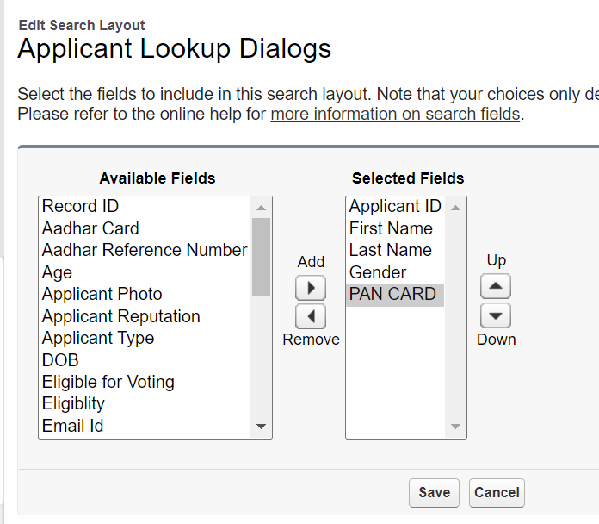

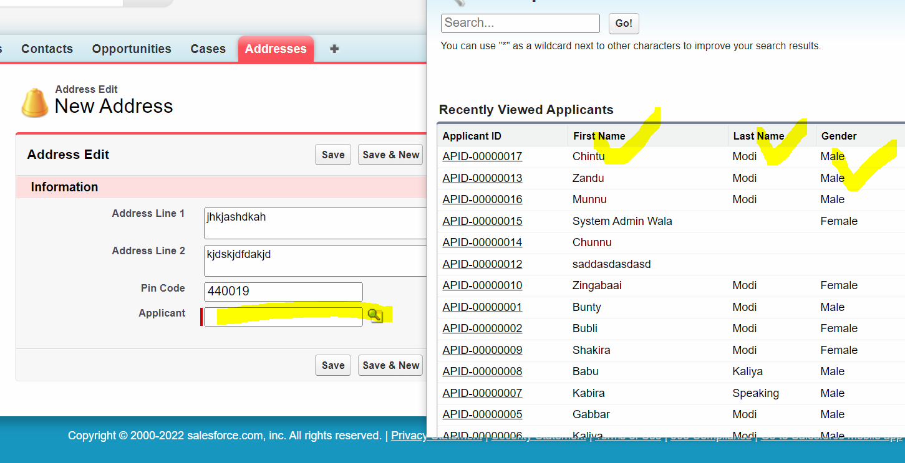

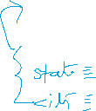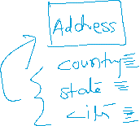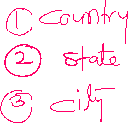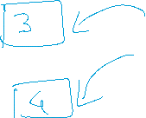

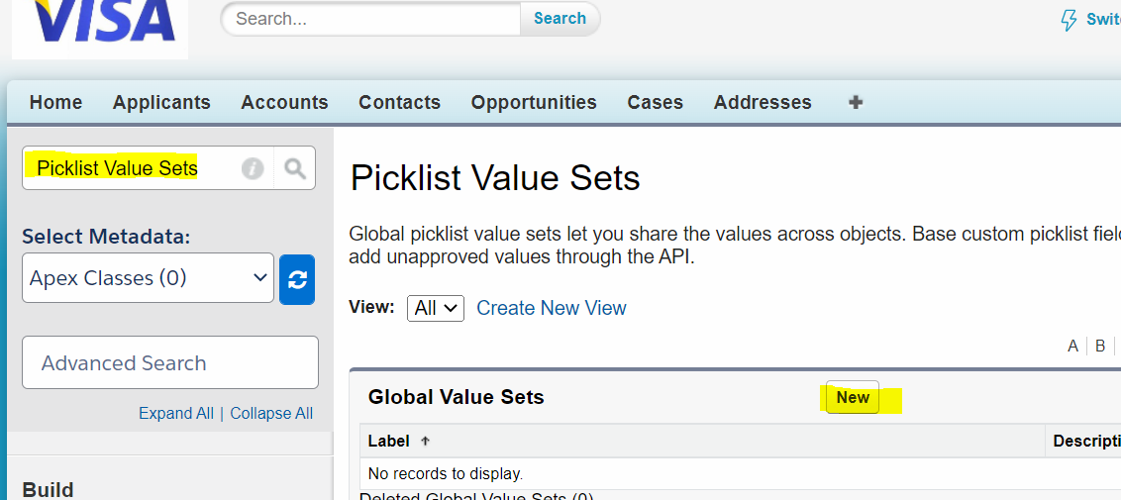

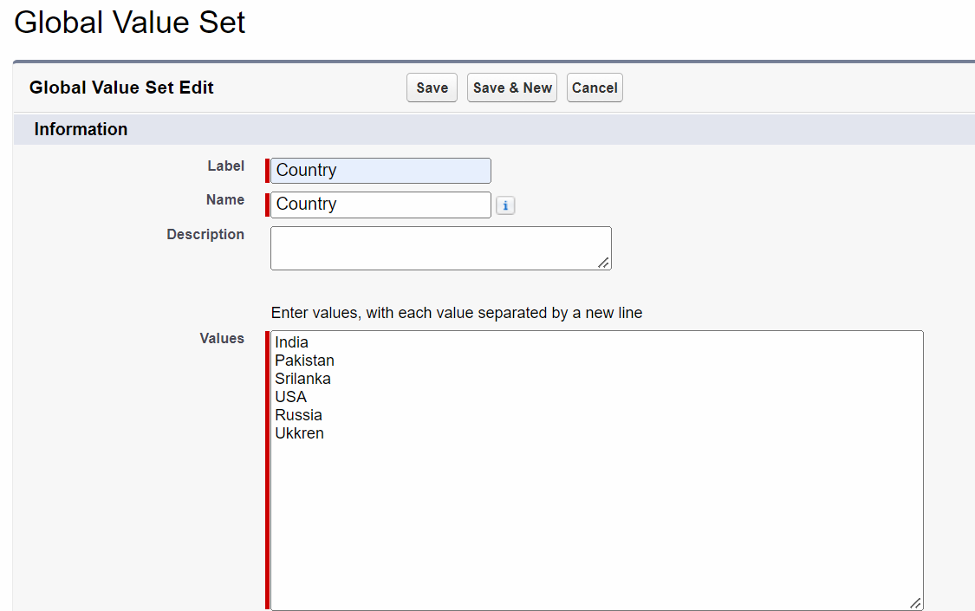

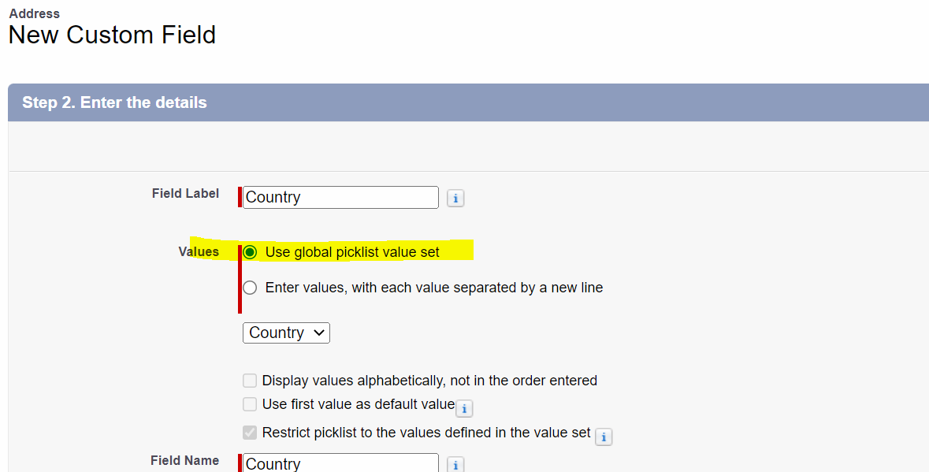



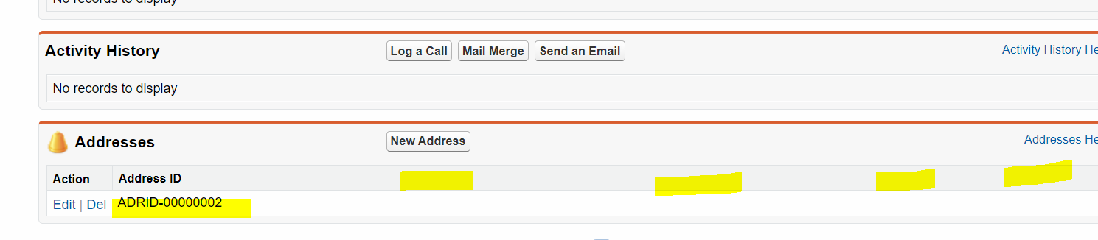

Applicant Page Layout:

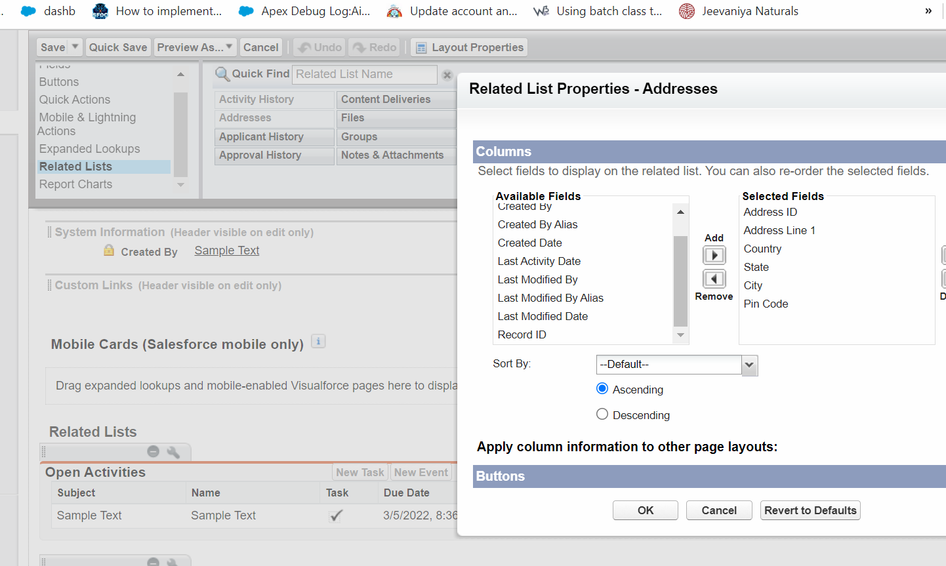

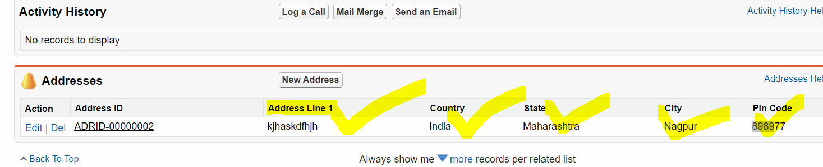

POINTS TO REMEMBER:

1] Master is mandatory while creating details records.

2] When we delete Master Record, then all the related details records get deleted Cascadingly.

3] There should be no any record exists in Details Object while creating Master-Details Relationship.

4] We can create Rollup Summary Field on Master Side.

1] Master is mandatory while creating details records.

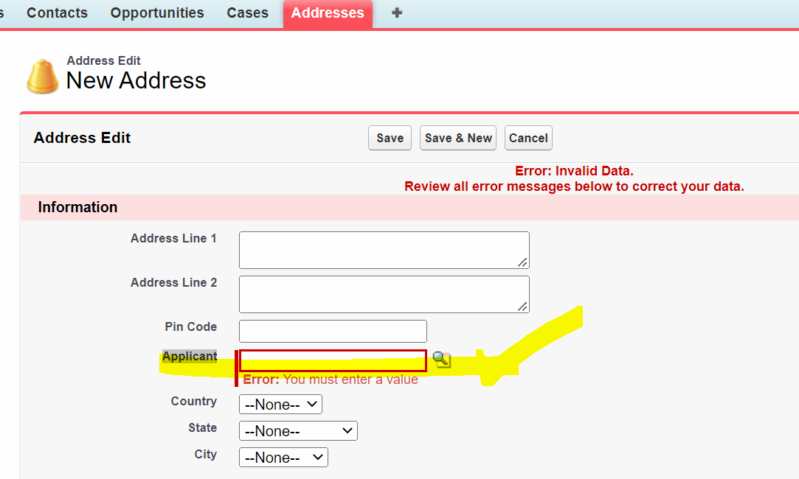

2] When we delete Master Record, then all the related details records get deleted Cascadingly.

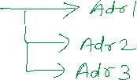

3] There should be no any record exists in Details Object while creating Master-Details Relationship.



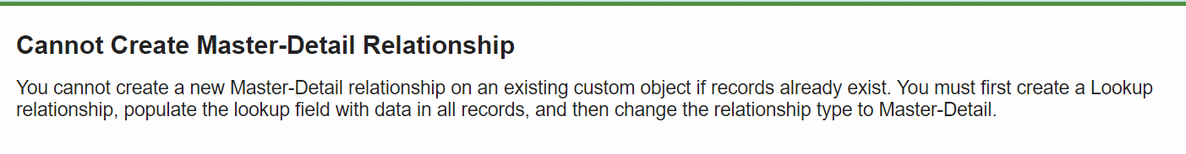

02 Solutions

A] Delete existing Address Records. (Ghatiya Tarika)

4] We can create Rollup Summary Field on Master Side.

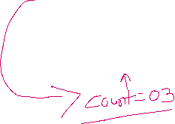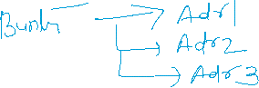

Rollup Summary Field:

It is a Read-Only field, which is used to apply Aggregate Functions (SUM, COUNT, MIN, MAX)

Over details Records.



COUNT:

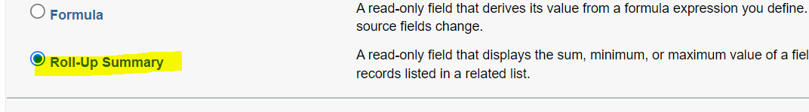

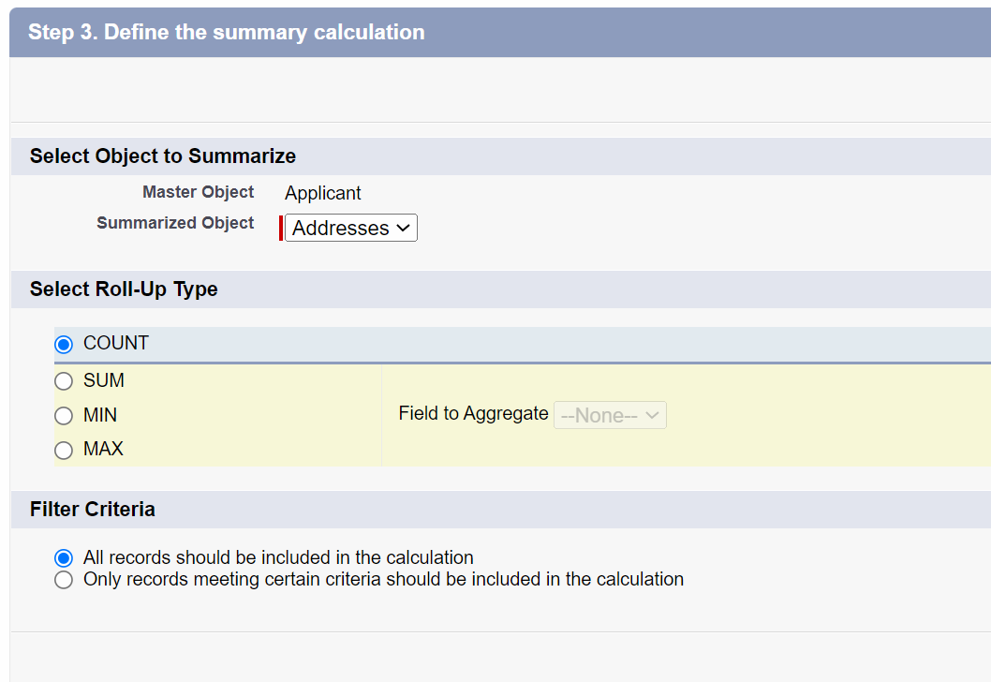

Female and Male wala locha…

OR( AND( Age__c <18, ISPICKVAL( Gender__c , 'Female') ) , AND(Age__c <> 30, ISPICKVAL( Gender__c , 'Male')))

Manager Wala Locha…

AND( ISBLANK( Subject) ,  
$Profile.Name = 'Manager'  
)